202002219

Hind Ebrahim Mohammed Busandal

**Student**

**ID**

**Student**

**Names:**

**Tutor:**

Sini

Raj

Pulari

**Due**

**Date:**

Wednesday,

20

th

Dec

202

3

by

11:55

p.m.

**Assessment**

**Title:**

**Learning**

**Outcomes:**

LO1

–

Demonstrate

critical

knowledge

and

understanding

of

the

fundamental

concepts

and

techniques

of

Data

Mining

LO2

–

Utilize

data

mining

software

to

solve

defined

and

undefined problems

LO3

–

Interpret and evaluate obtained numerical and graphical data to recommend the best

model to

be

used

for

prediction

purposes

Individual

Project

IT7405

–

Web

development using

Non

-

relational

Databases

**Course**

**Code**

**and**

**Title:**



**Bachelor**

**of**

**ICT**

**Assessment**

**Cover**

**Sheet**

Complete

and

attach

this

cover

sheet

to your

assessment

before submitting

**Late Rule: The maximum grade granted for late submission is 60 % for up to 2 calendar days. A grade of 0 will be allocated for submission after 2 days**

***By submitting this assessment for marking, either electronically or as hard copy, I confirm the following:***

* *This assignment is* ***my own work***
* *Any information used has been properly referenced.*
* *I understand that a copy of my work may be used for moderation.*
* *I have kept a copy of this assignment*

**Assessor:**

**Date**

**of**

**Marking:**

**Grade/Mark:**

Do

not write

below

this

line. For

Polytechnic

use

only

*.*

IT7405 Individual Project: Pet Adoption Website

Done By: 202002219 Hind Ebrahim Mohammed Busandal

Table of Contents

Task 1 - Problem Statement Formulation and definition 4

- Motivation 4

- Problem Statement / Project Definition 4

- Functionalities 4

Task 2 - Creating the No-SQL MongoDB Database and Data Modeling 6

- Creation of a No-SQL MongoDB 6

- CRUD operations 7

• Create 7

• Read 8

• Update 10

• Delete 12

- Usage on MongoDB Index 12

- Query Diagnosis and Analysis 13

Task 3 - Using Django to build the Web Application using Bootstrap 15

- Creation of VirtualEnv for Django 15

- Organization of files 17

- Mapping python objects with mongo DB 19

- Django template language 20

- Project settings used. 22

- Connectivity of Django with MongoDB 22

- Model –View-Template 24

- Django Admin site 26

- Django forms 27

- Incorporation of Bootstrap 28

Task 4 – Overall GUI and working, Report, GIT hub, Video and Reflection 31

• Overall Navigational GUI 31

• GIT hub 34

• Video 34

• Reflection 34

# Task 1 - Problem Statement Formulation and definition

## Motivation

Many people who are pet owners or seek to be a pet owner face difficulties in the connectivity of the pet community. People may use social platforms to look for pets or put them up for adoption, and they often have trouble getting all the information they need or contacting a second party effectively. In addition, many people encounter scams and fraud when using unreliable platforms. We aim to create an authorized and trusted website that gathers all pet lovers.

## Problem Statement / Project Definition

Pet Hub is an online website that targets the pet community whether they want to adopt or put pets up for adoption. It offers a solution to some of the most common issues faced when looking for a pet or putting one up for adoption. Seeking to create a safe reliable connection between owners and potential adopters, by simplifying the adoption process thus making it faster, easier, and successful.

The first feature in PetHub is a pet library that lists all the current pets in the database collection including their picture, name, age, gender, a short description, status, and a button that takes you to their pet profile. This allows users to see all pets in the database in one page. Also, Pet Hub offers Pet profiles with unique identification for every pet. This helps the potential adopter to find information about the pet and provides authenticity and originality. In addition, Pet Hub has a search option to help adopters find exactly what they are looking for without having to go through every available pet. Owners can put a pet up for adoption by filling out a form for adding pet.

## Functionalities

1. **Pet Library:** A website page called “Our Pets” that shows all the pets in the database including some of their most required specifications such as Name, age, gender, and a short description about the pet. This allows any pet that’s added to the database collection to automatically be listed in a single page with a single block of code.
2. **Pet profile:** Unique pet profiles with unique pet IDs and owner IDs and their name, breed, age, gender, size, and 3 personality traits. It helps the user view special characteristics of the pet in addition to the availability and status. Pet profile also includes interactive options so users can apply for adoption or book a meet-up. A pet owner is responsible for creating a profile for all their pets by using the “Add Pet” option.
3. **Search function:** A search function allows users to navigate through a wide range of pets by entering a keyword and narrowing down their search results. Users can input criteria such as the desired pet type (dog/cat), age, gender and status ensuring that users find exactly what they are looking for. Once a user inputs data in the search engine, a unique list of available pets will appear according to their search.
4. **Add pet:** The add pet form enables pet owners to list a pet for adoption. If a pet owner would like to list the put for adoption, must go to the pet library, log in / sign up for the add pet option to show, and fill in the form that’s adds the pet automatically to library.
5. **User authentication:** The login and register functionality gives PetHub a sense of authentication that divides readers and actual users. In case you are just scrolling through the website you can view most of the pages normally. However if you wish to add pet to the database you must register and log in or else the option would not show for you.

# Task 2 - Creating the No-SQL MongoDB Database and Data Modeling

## Creation of a No-SQL MongoDB

Step 1: Connect to compass

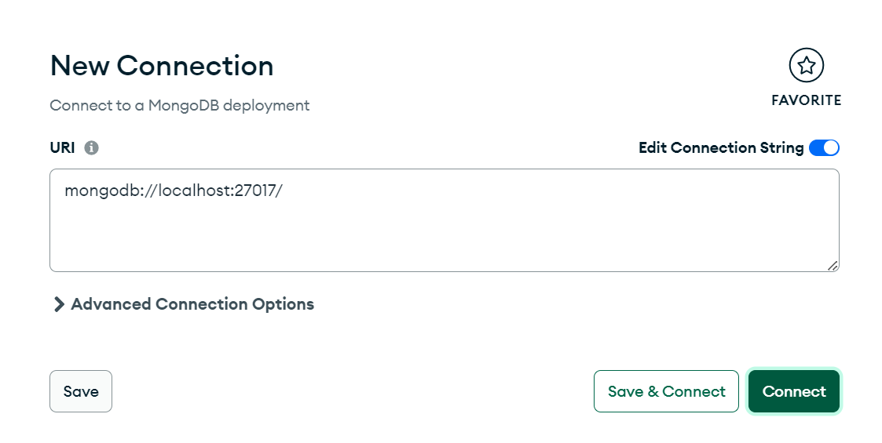

Step 2: create database and collection in compass

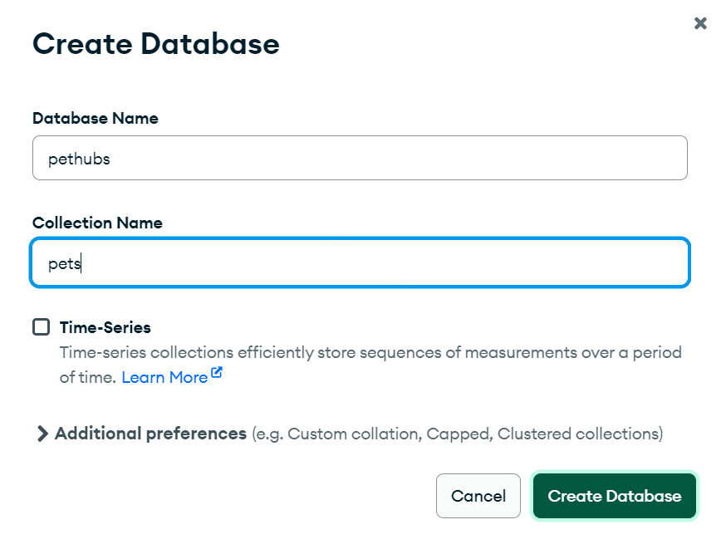

Go to Mongosh and type use (databasename)

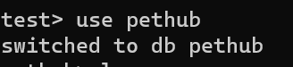

To run any commands you must use the collection pets_pet

Eg. db.pets_pet.

## CRUD operations

### Create

Add pet to database collection using add pet page

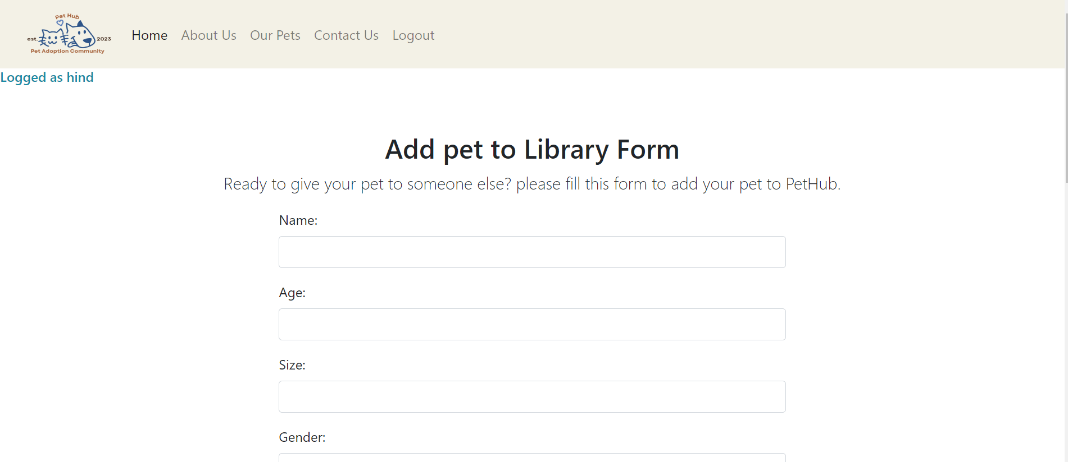

Fill information

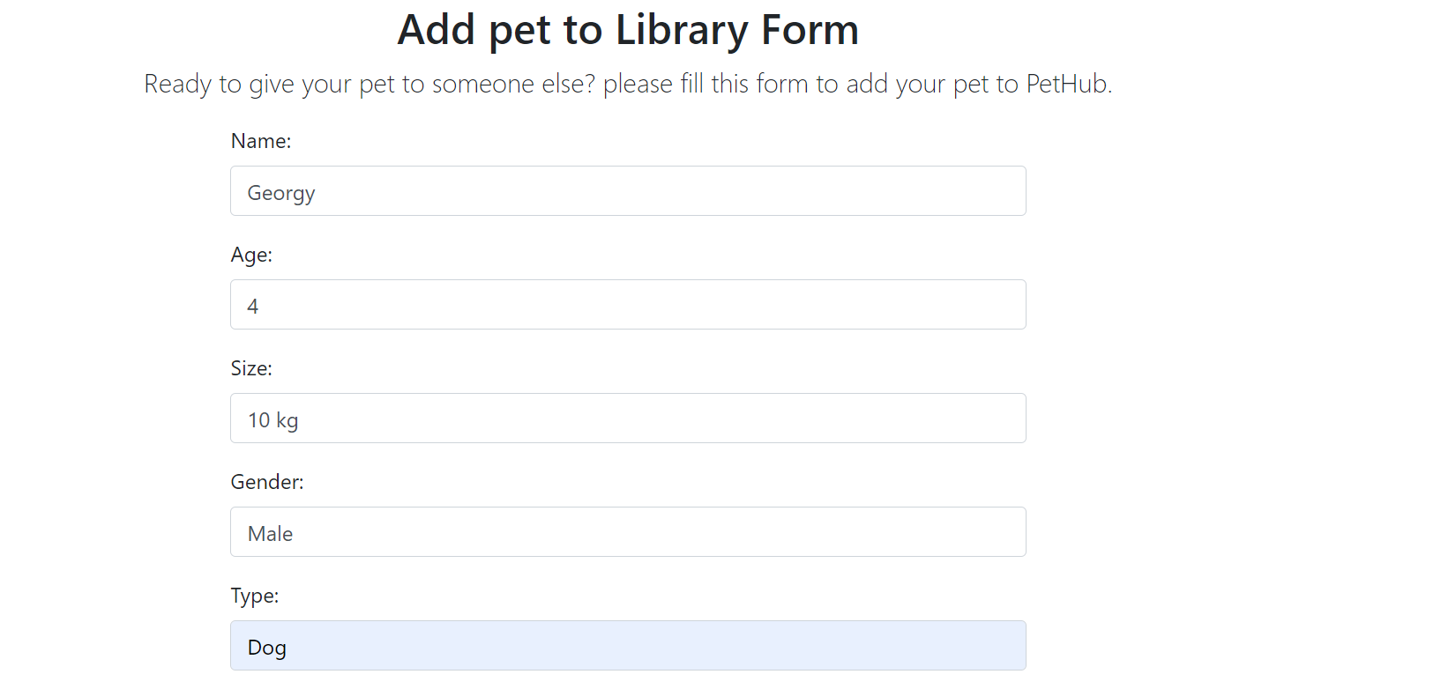

For the image add the path in Django project

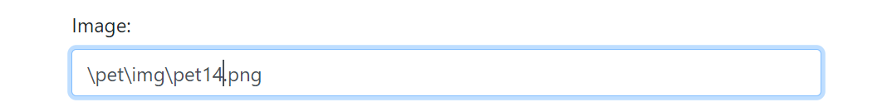

Add pet

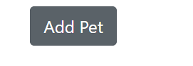

Now the pet will automatically show in both the collection in MongoDB and Pet Library in Website

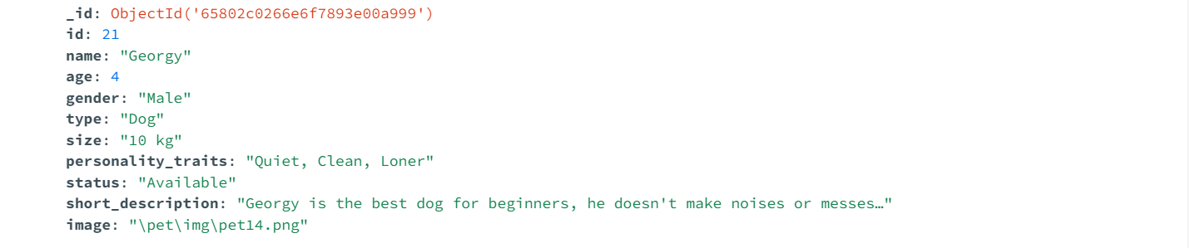

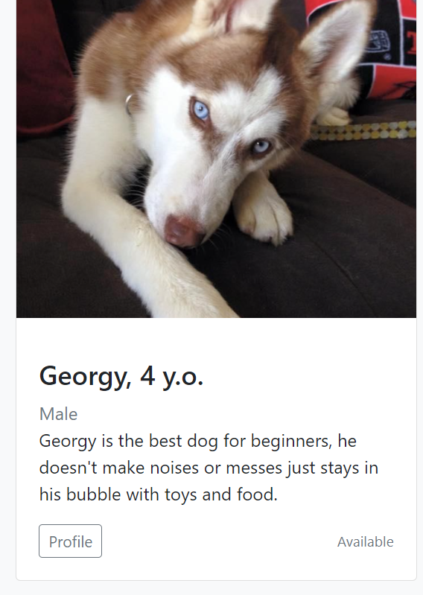

### Read

db.pets_pet.find()

this command will show all the documents in the collection “pets_pet” in the database “pethub”

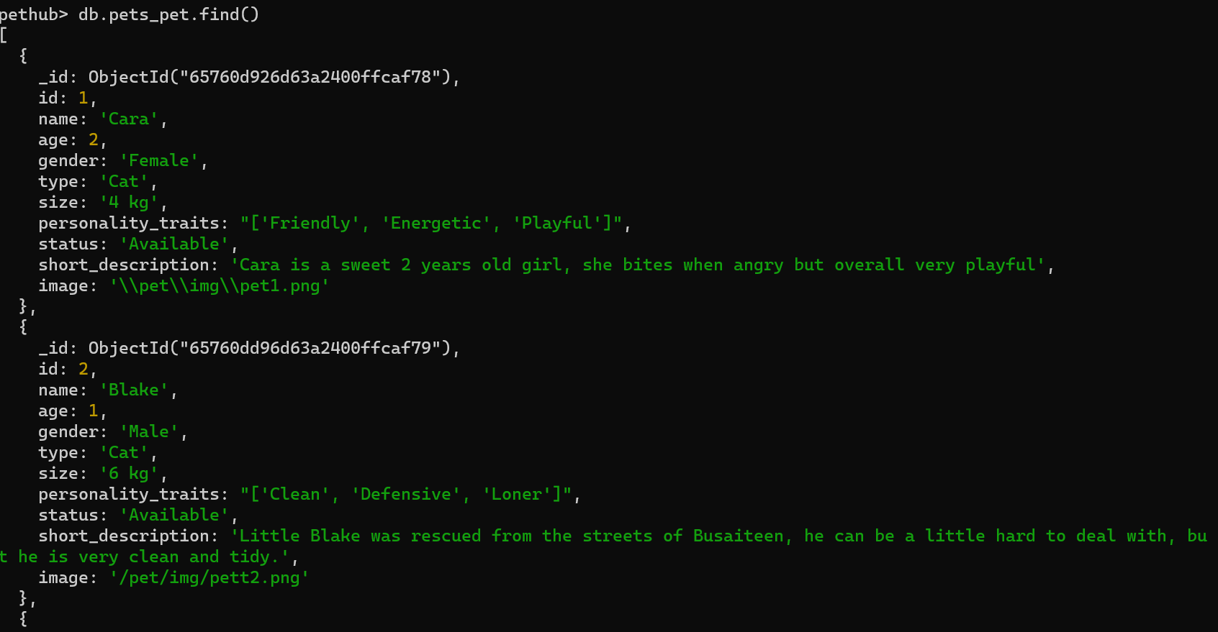

**Equality matching:** db.pets_pet.find({ age: { $lt: 2 } })

this command will show all pets in collection with age less than 2

Output:

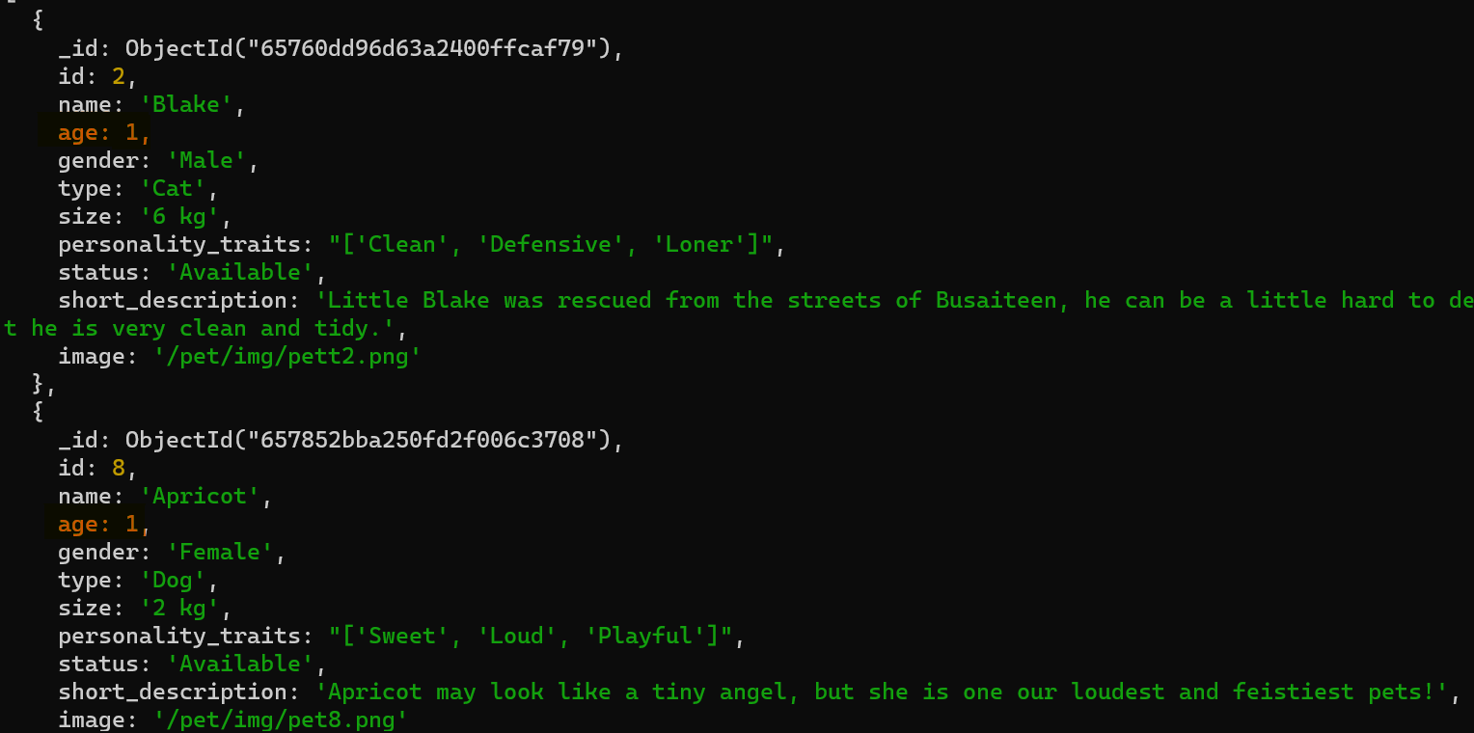

**Field selection**: db.pets_pet.find({}, { name:1, type: "Dog"})

This command will show all the names of pets of type Dog

Output:

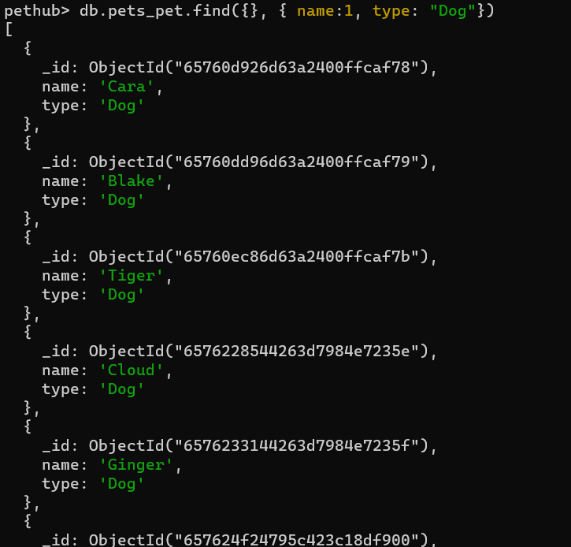

### Update

For this command we will update the status of pet Cara from Available to adopted

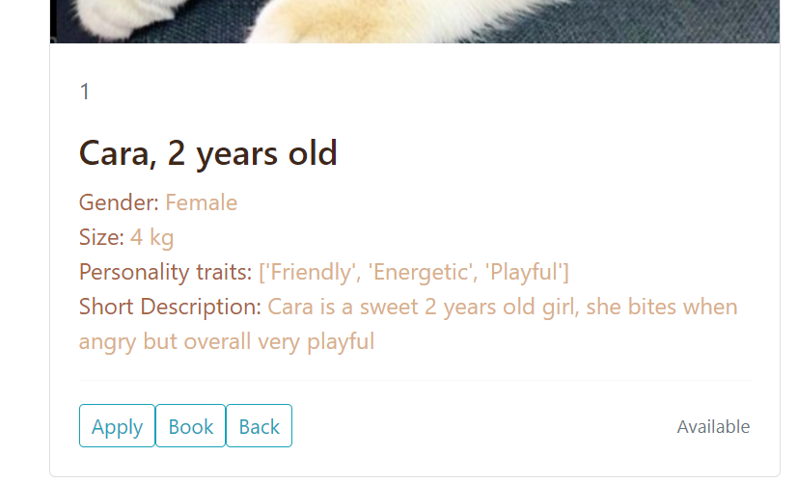

Command db.pets_pet.update({ name: "Cara" }, { $set: { status: "Adopted" } })

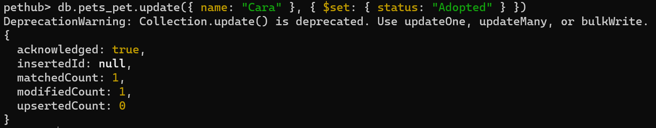

Now we can go back to Cara’s profile and refresh to see update

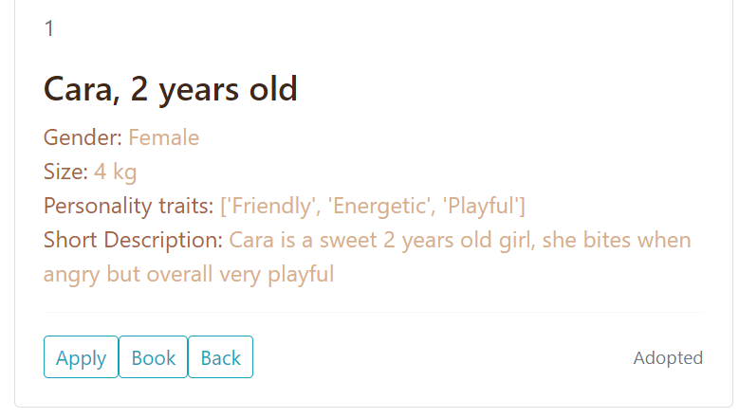

In the second command we will update all pets with age 3 and set it to 4

First, we will find all the pets with age 3 using command db.pets_pet.find({ age: 3 })

And there are 3, ginger, stormy, and susan

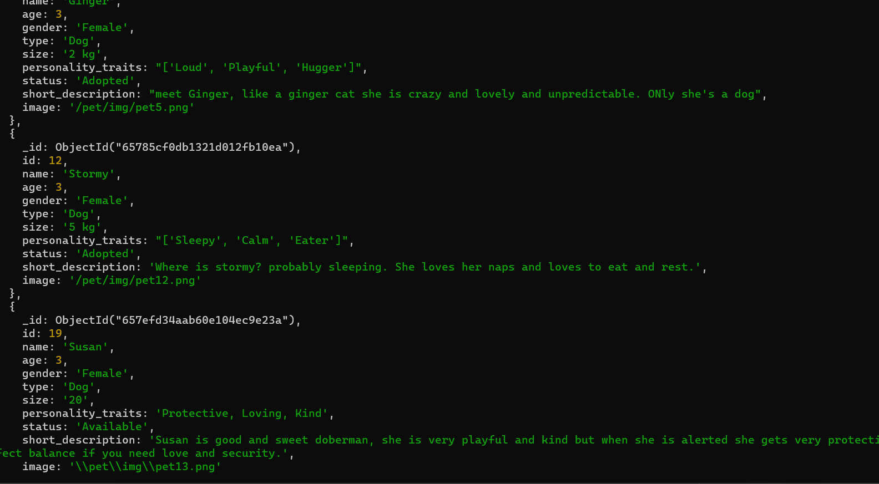

We will use command updateMany command db.pets_pet.updateMany({ age: 3 }, { $set: { age: 4 } })

matchedCount and modifiedCount are 3 so we have updated documents successfully.

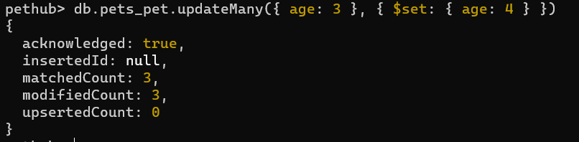

We can also check the library for updates

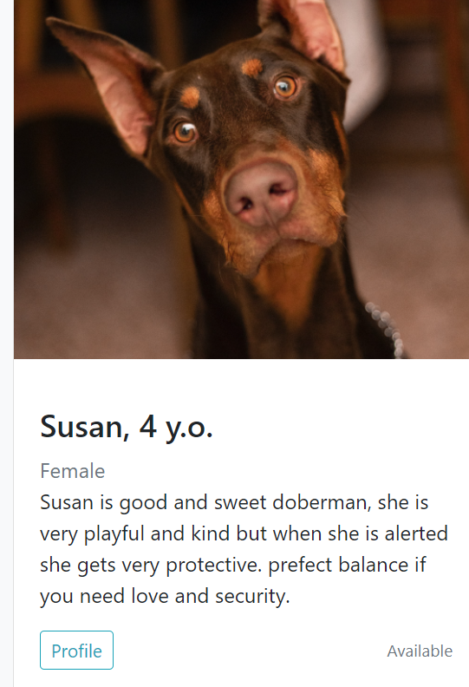

**Replace document:** We will replace Georgy’s information.

Before replacements

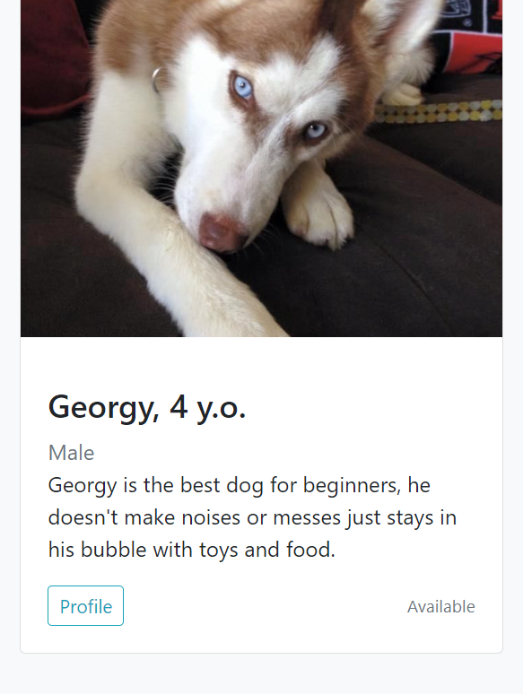

we will update some information using the command db.pets_pet.replaceOne({ id:15 }, { id:15, name: 'George', age: 5, gender: 'Male', type: 'Dog', size: '15 kg', personality_traits: 'Quiet, Clean, Loner', status: 'Available', short_description: "Georgy is the best dog for beginners, he doesn't make noises or messes, just stays in his bubble with toys and food.", image: '\\pet\\img\\pet14.png' })

Output:

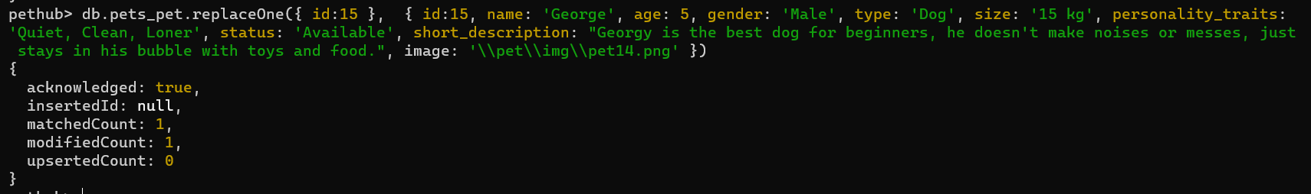

Here you can see that the details have changed in the library.

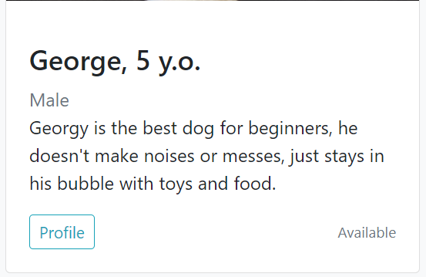

### Delete

deleteOne: we will delete the pet with id: 13 using this command db.pets_pet.deleteOne({ id: 13 })

output:

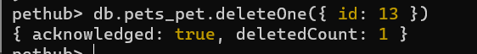

DeleteMany: we will deletes pets with ids 14, and 15 using this command: db.collectionName.deleteMany({ _id: { $in: [14, 15] } })

Output:

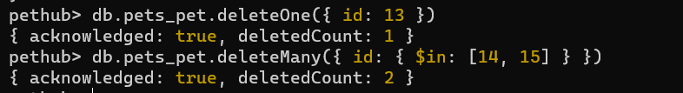

## Usage on MongoDB Index

**Creation**: I will create an index that will speed up the process of retrieving pets that have age as 1 using command db.pets_pet.createIndex({age:1})

Output:

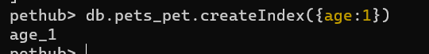

To verify creation we can use code db.pets_pet.getIndexes()

Output: 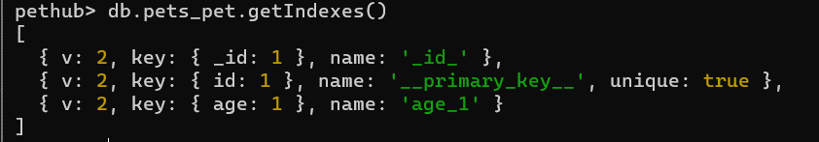

**Usage**: we will use query diagnosis command to see how out index is used by using this command db.pets_pet.find({ age: 1 }).explain('executionStats')

This allows you to get information about the execution of a query, including its execution statistics. We will monitor how many keys have been examined to get all the pets that have age as 1.

Output:

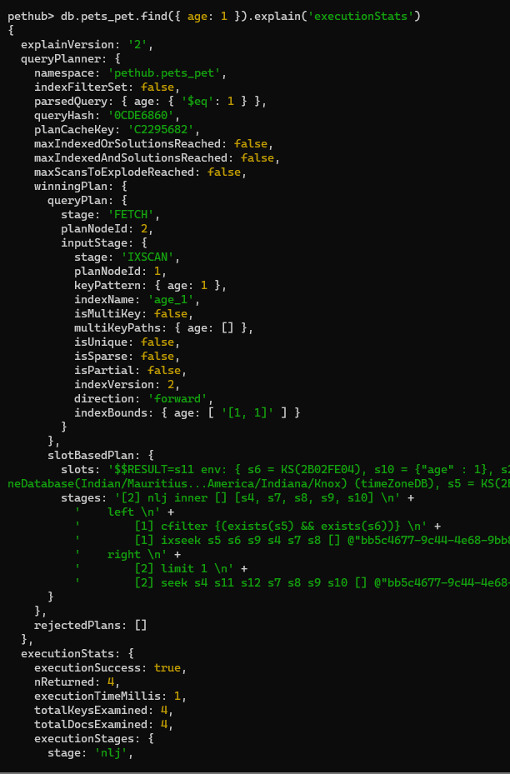

Explanation: without index, the find will have to go through all 12 pets in the collection and match them with the condition. After creating the index, the find will automatically use the index and return 4.

## Query Diagnosis and Analysis

**Query 1**: db.pets_pet.find({ age: 1 }).explain('executionStats')

This query diagnosis allows you to get information about the execution of a query, specifically its execution statistics. It will return the total execution time, the number of documents examined, the number of documents returned, and other relevant metrics. This helps in understanding the performance characteristics of the query and identifying any potential optimizations.

Output:



**Query 2**: an aggregate function that returns the number of Adopted pets in the collection: db.pets_pet.aggregate([{ $match: { "status": "Adopted" } }, { $group: { _id: null, count: { $sum: 1 } } }]);

Output:



# Task 3 - Using Django to build the Web Application using Bootstrap

## Creation of VirtualEnv for Django

Steps of creating a virtual environment

Step 1: Launch Anaconda prompt or open Anaconda Navigator to launch CMD.exe prompt.

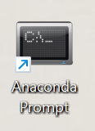

Or

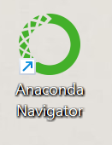

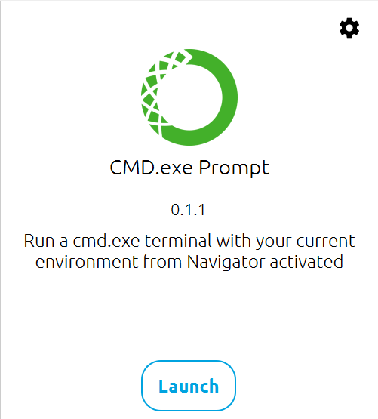

Step 2: Go to the directory you want to create your project in (use CD).

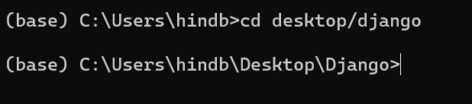

Step 3: Run this command to create the virtual environment: conda create --name (name) Django

In our case: conda create --name djangoEnv Django

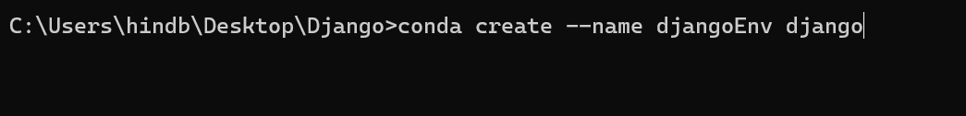

Step 4: Activate Virtual Environment by using command : activate (ve name)

In our case: activate djangoEnv

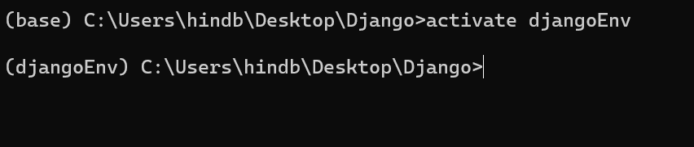

Step 5: make sure to install all the requirements for project (use pip list to see current installations)

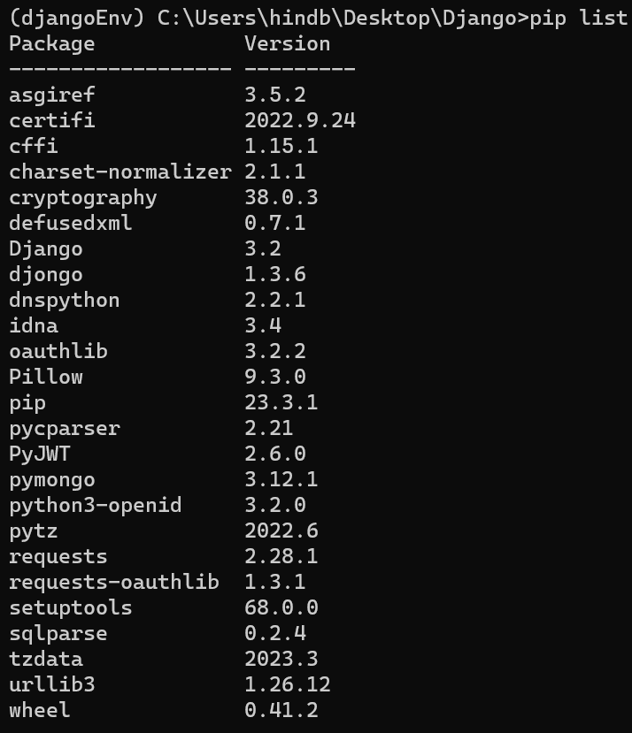

Step 6: Use pip install (package==version) to install packages

For example: pip install sqlparse==0.2.4



Step 7: create the project using command: django-admin startproject <app-name>



Step 8 : go the new created folder, and list directory contents

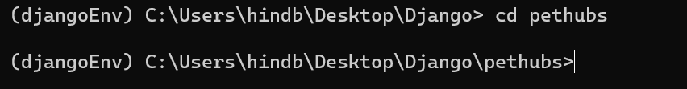

All these files are automatically created for you

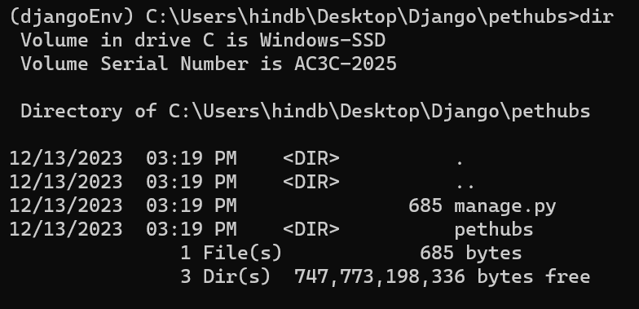

Step 9: create the application using command: python manage.py startapp <app-name>

In our case python manage.py startapp pets



Step 10 : go the new created folder, and list directory contents



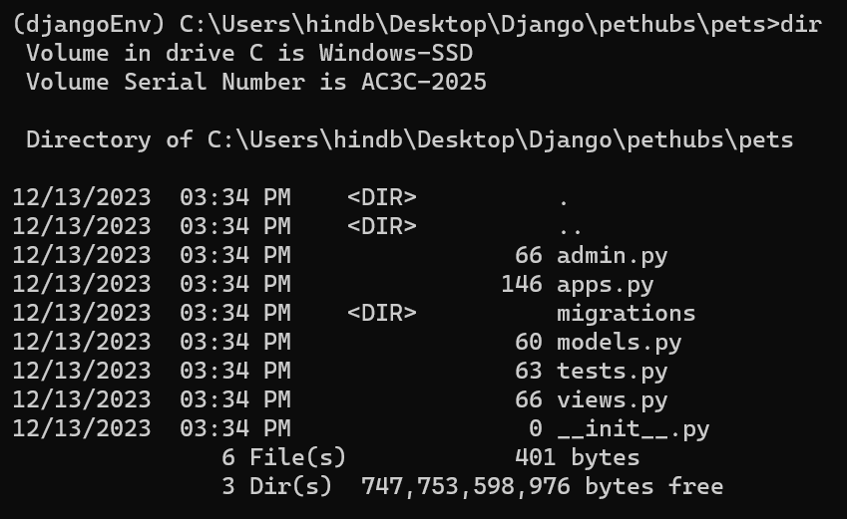

All these files are automatically created for you.

## Organization of files

When creating a Django project, a main project directory is automatically created. In that directory there are a few other directories for applications including the **manage.py** file

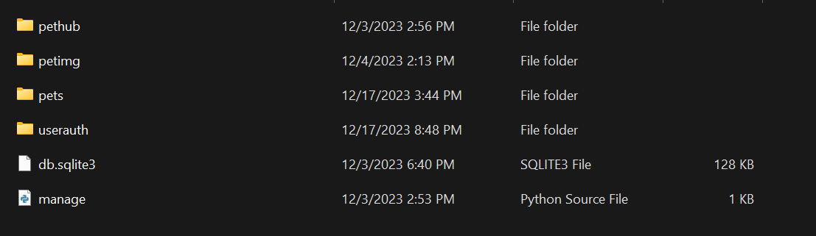

When creating a project/ application a set of files are automatically created as well.

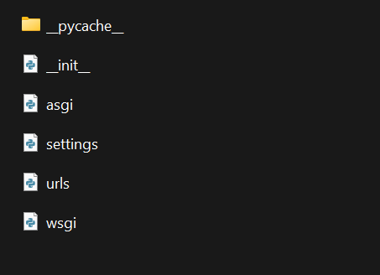

Inside the main application you will create a template folder and a static folde

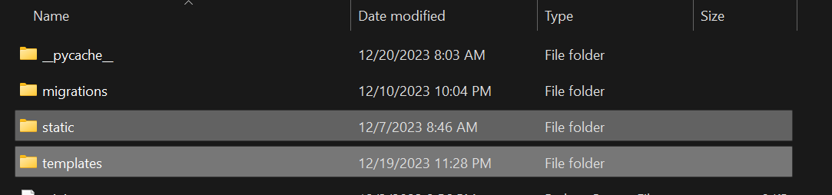

The template folder will contain all the templates (html files) for your project

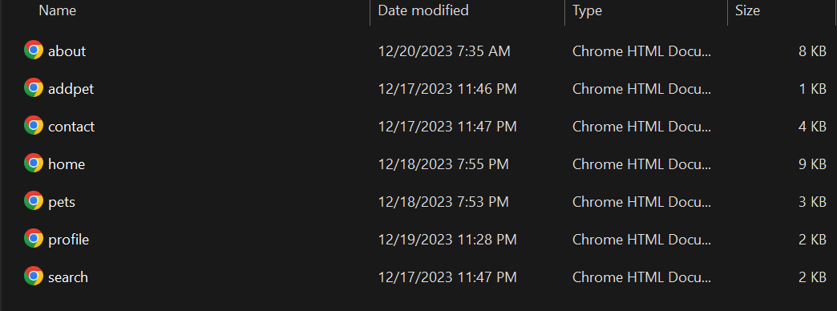

The static folder will contain a folder called CSS that contains the CSS stylesheet linked to all these templates

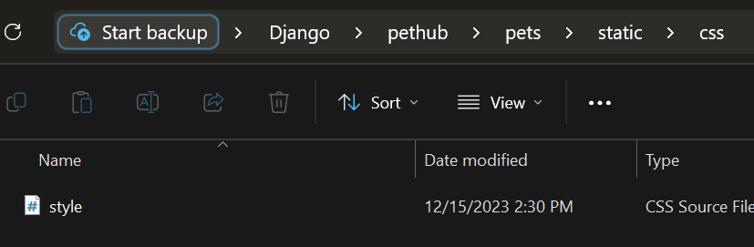

## Mapping python objects with mongo DB

For the pet_list object used in the “pets” page we use the Pet.objects.all() to retrieve all documents in the database collection

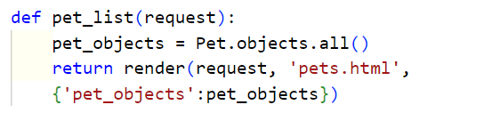

For the profile view used in the “profile” page we use the Pets.objects.get() to retrieve one document in the database collection with the id that matches the pk passed in the function

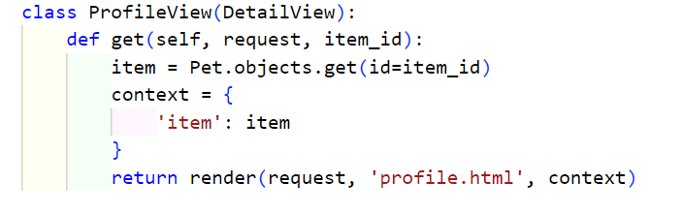

For the add pet form we use the .save() command to create a new document in database collection

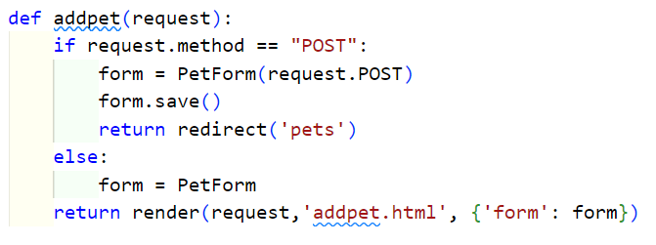

For the search function we used the Pet.objects.filter() to retrieve a list of Pet objects that match certain search criteria.

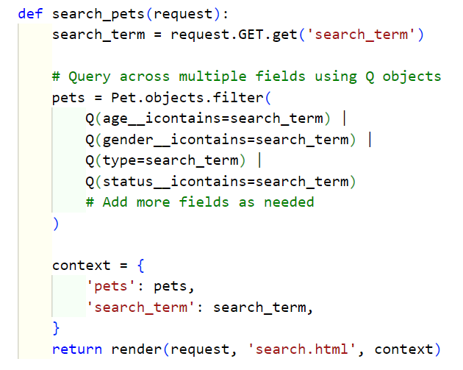

## Django template language

Django template language is used for many things within the project including:

**using {% %}**

Loading static for pages

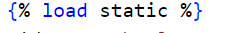

Link the stylesheet

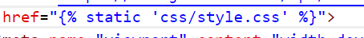

To render content based on the authentication status of a user.

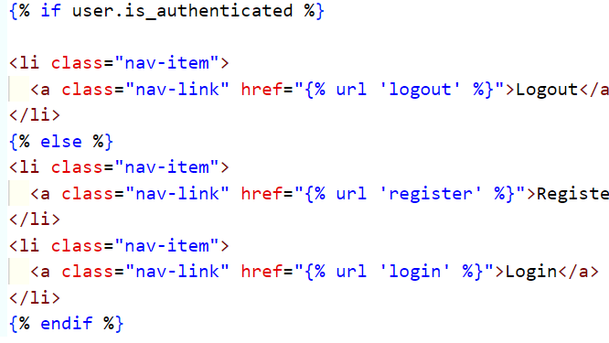

to use a link for the page enclosed in {% %} such as the navigation bar

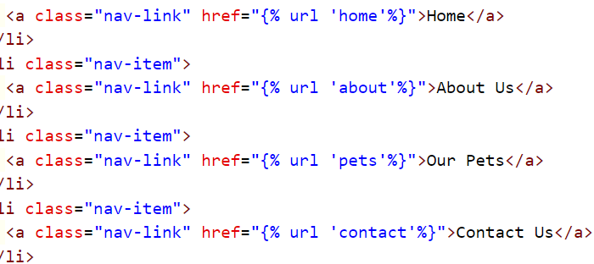

To Inherit structure from template

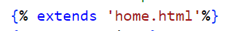

To loop through the pet list function

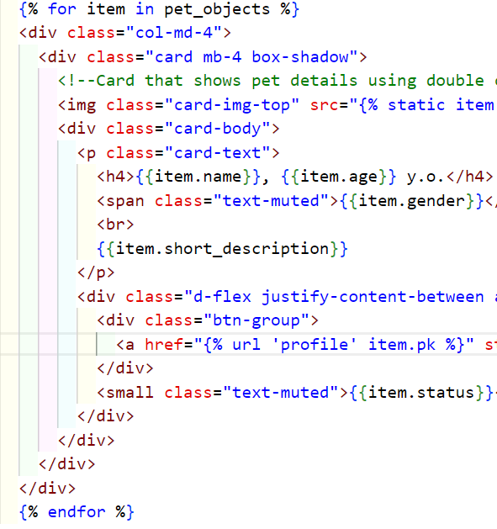

to include a Cross-Site Request Forgery (CSRF) token in HTML forms, not using it will result in a CSRFTokenError and the form submission will be rejected by Django.

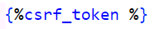

**Using {{}}:**

display the username of an authenticated user, or a default value ('Guest' in this case) if the user is not authenticated or if the username is not available.



to insert data from context variables into the HTML template

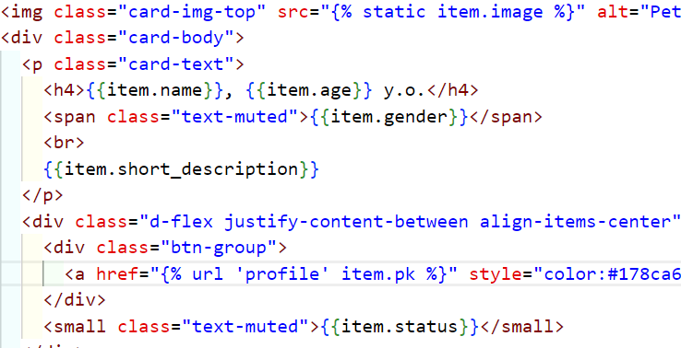

{{form.as_p}} template variable used to render a form as a series of <p> elements.

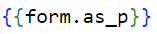

## Project settings used.

Before creating our website, we must amend the settings of our project

Step1: Go to VS code or any code editor desired



Step 2: Click open folder, and choose project name “pethub”, and select folder.

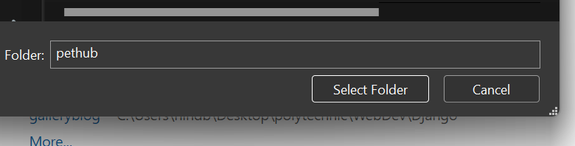

Step 3: open pethub/settings.py and add the application name “pets” to installed apps

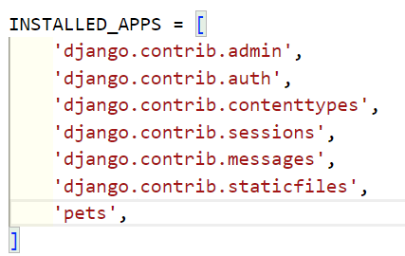

## Connectivity of Django with MongoDB

Step 1: In pethub/settings.py, Adjust the database section to your project name

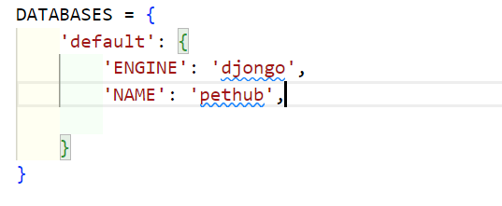

Step 2: connect to MongoDB compass



Step 3: On the left you can see all your current databases, Click on the arrow

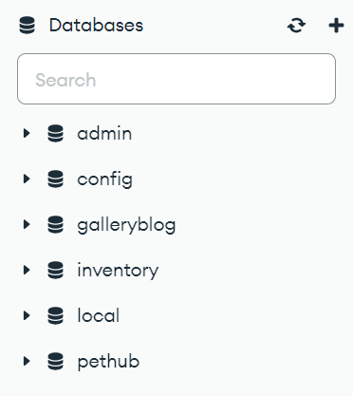

Step 4:



## Model –View-Template

The Model-View-Template (MVT) pattern separates the data (Model), the logic (View), and the presentation (Template) components of a web application. First we have to create our Model in this project it’s the pet.

Step 1: Go to pets/models.py, import models and user and create your Model and all its attributes

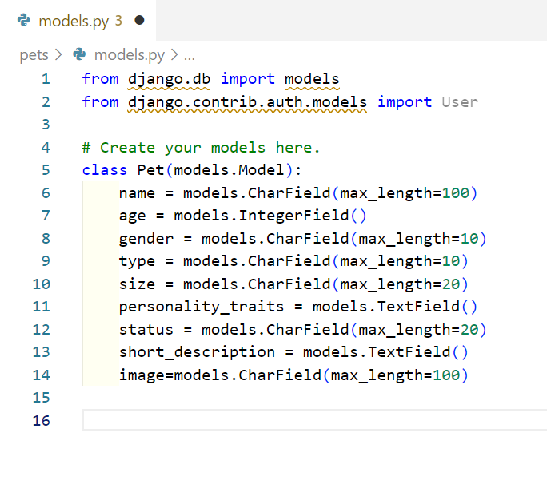

Step 2: Update Admin.py by registering the Pet

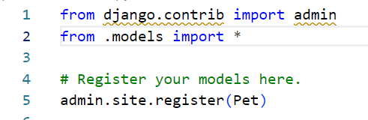

Step 3: Go back to prompt, make sure you’re in the project folder “Pethub” and not application, and run **python manage.py makemigrations**



Step 4: then run **python manage.py migrate**

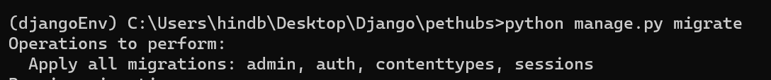

Step 5: create views in pets/views.py

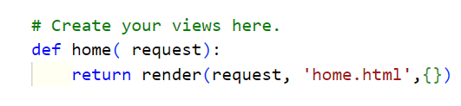

Step 6: Create Templates folder in pets and create templates (html files)

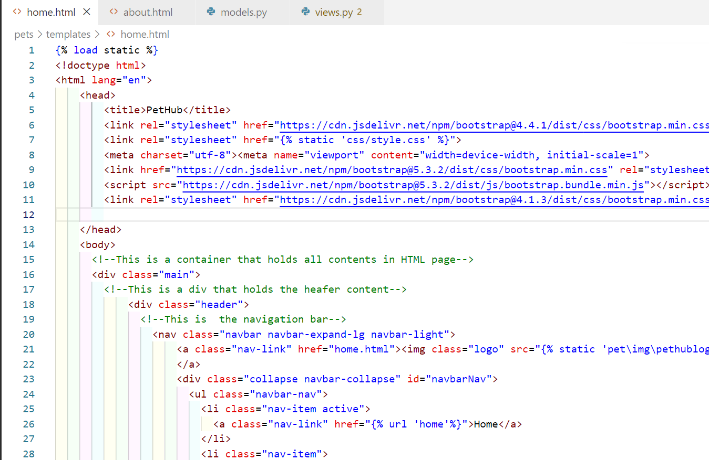

Step 7: Define url in pets/urls.py

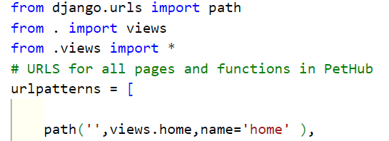

Step 8: Go back to your project folder, and run **python manage.py runserver**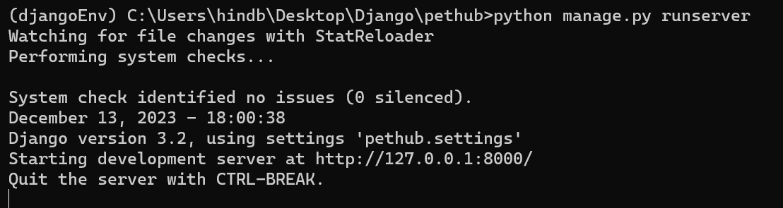

Step 9: Go to <http://127.0.0.1:8000> and your page will show

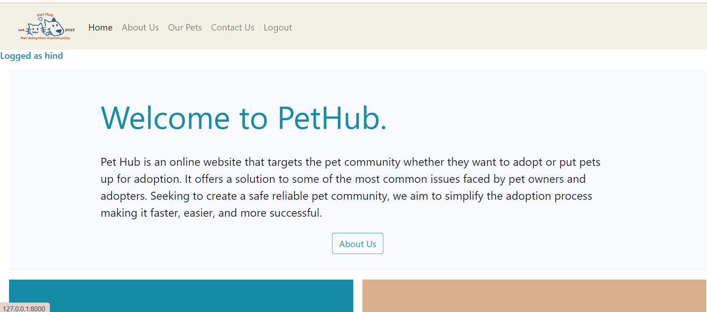

## Django Admin site

Step 1: In your project folder, run **python manage.py runserver**

Step 2: Go to <http://127.0.0.1:8000/admin> and your model will show in site administration

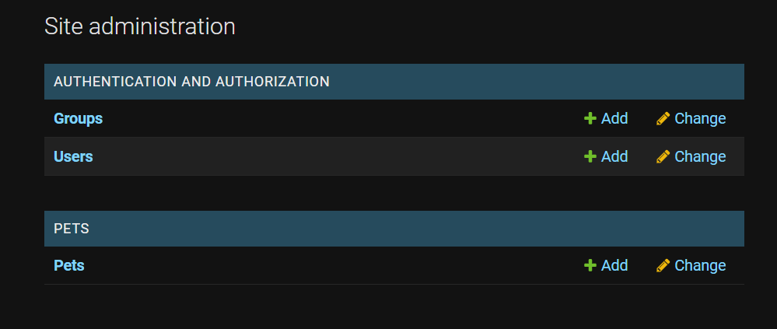

Step 3: You can add Pets and manage objects and users from the admin site

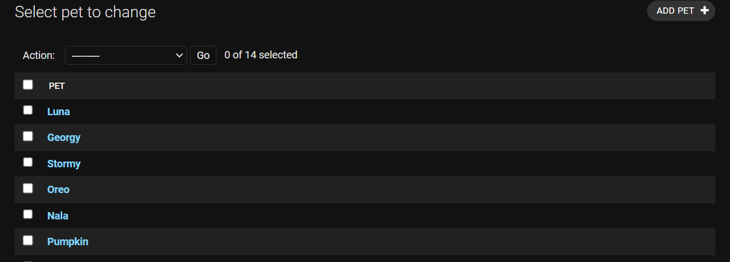

## Django forms

Step 1: go to your main application “Pets” and create a new file called forms.py

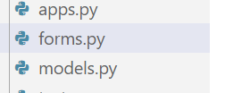

Step 2: import statements for forms, ModelForm, and model “Pet”

django import forms

from django.forms import ModelForm

from .models import Pet

Step 3: create a pet form

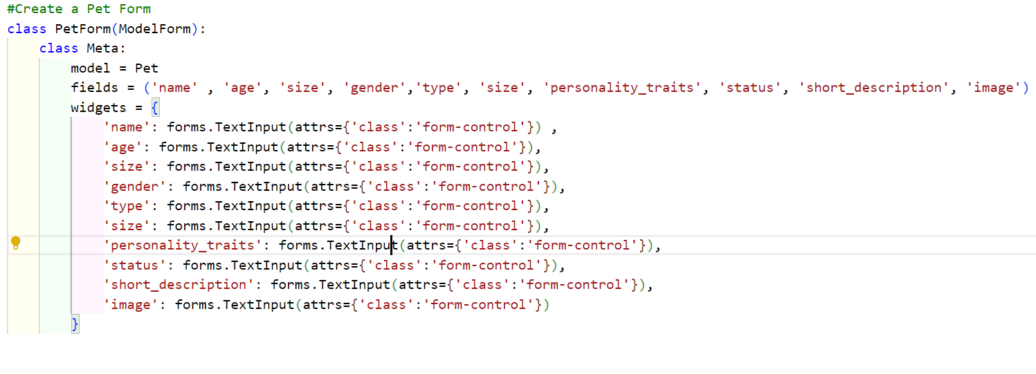

Step 4: Go to pets/views.py and import form

from .forms import PetForm

from django.http import HttpResponseRedirect

Step 5: create a function

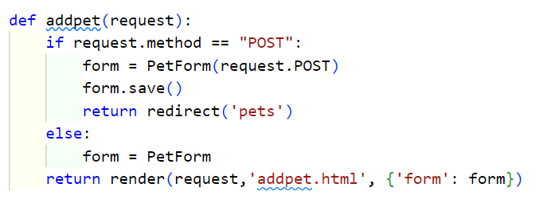

Step 6: create a addpet.html and add the form object

 <form action="" method ="POST">

            {%csrf_token %}

            {{form.as_p}}

            <button class ="btn btn-secondary">Add Pet</button>

        </form>

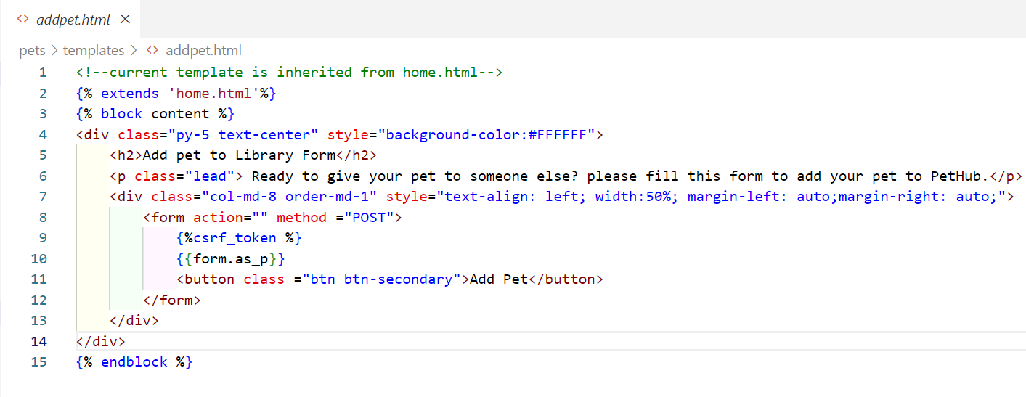

Step 7: go to pets/urls.py and add url pattern

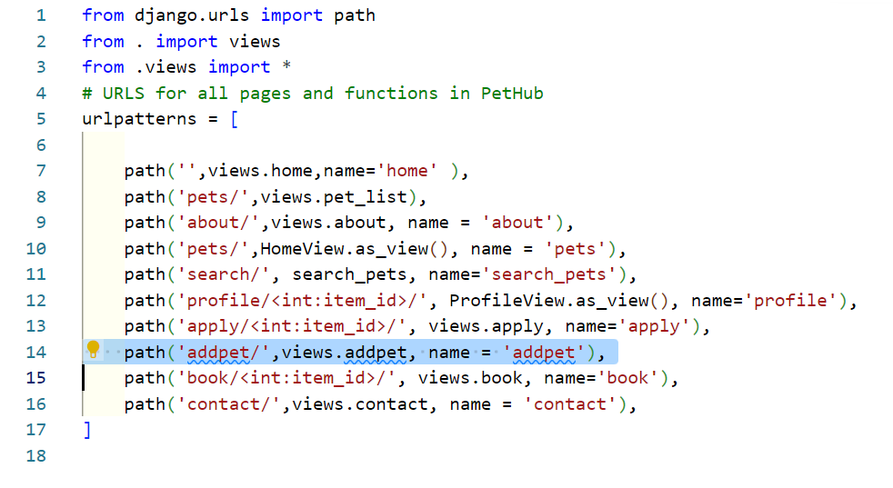

## Incorporation of Bootstrap

Bootstrap is a famous front-end framework which provides pre-designed components and stylesheets. Including Bootstrap in the PetHub website offers an overall visually appealing and responsive website with less development effort.

Step 1: Google Bootstrap element you desire, in my case it is Bootstrap Homepage

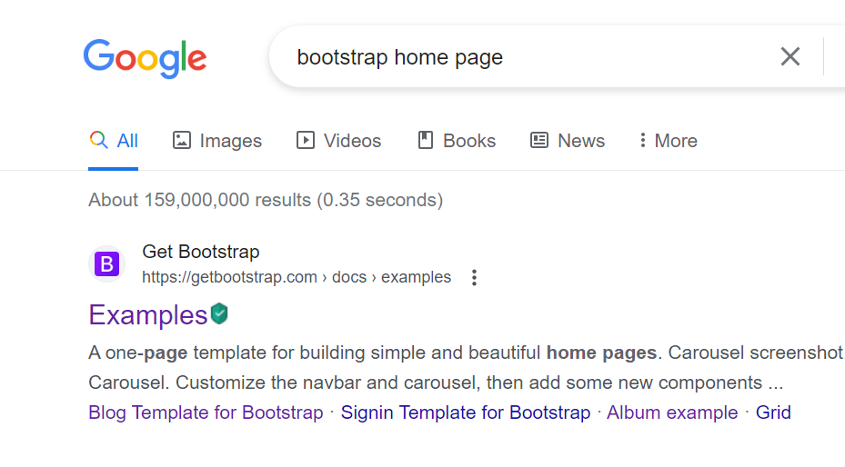

Step 2: Find a template that you like, I used: <https://getbootstrap.com/docs/4.0/examples/product/>

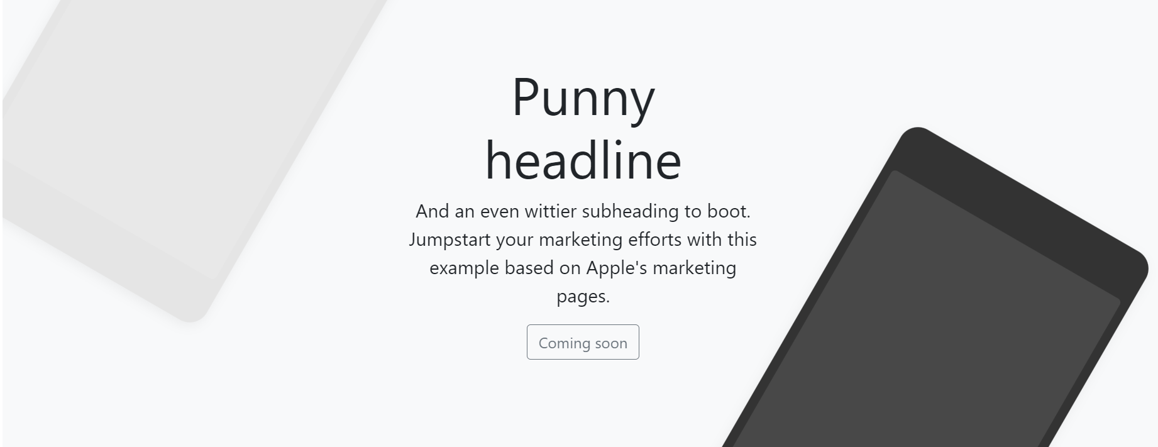

Step 3: right click, scroll down ,View page source

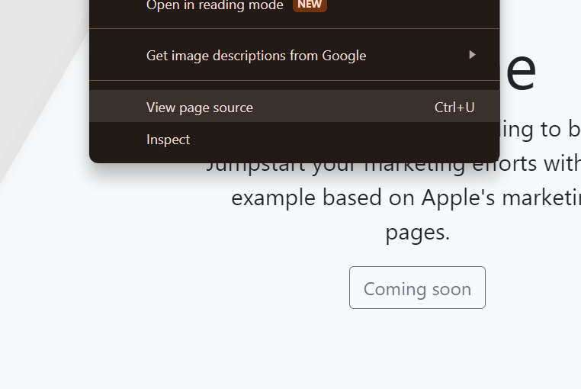

Step 4: Copy the desired code part to use in your site.

Step 5: link the cdn code in the head section of your page

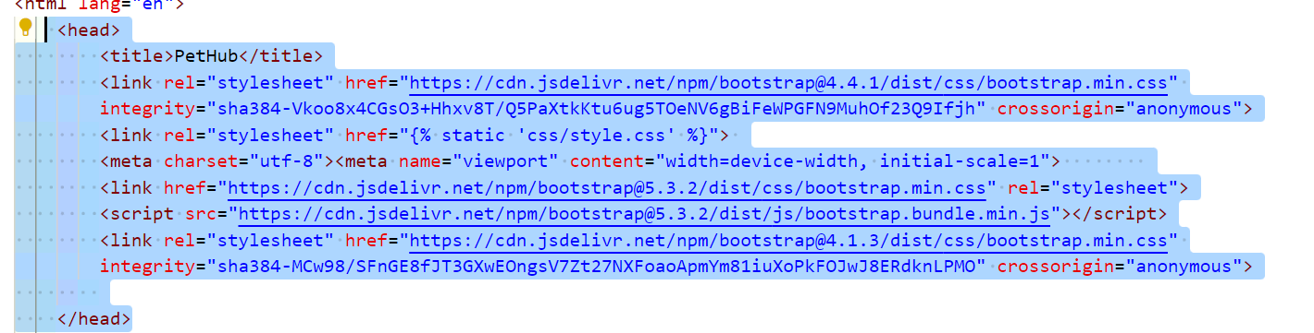

All Bootstrap templates used in PetHub site:

Home page: <https://getbootstrap.com/docs/4.0/examples/product/>

About Us page: <https://getbootstrap.com/docs/4.0/examples/carousel/>

Our Pets page: <https://getbootstrap.com/docs/4.0/examples/album/>

Apply/Book page: <https://getbootstrap.com/docs/4.0/examples/checkout/>

Many elements have been used and reused in different pages to maintain consistency in site.

# Task 4 – Overall GUI and working, Report, GIT hub, Video and Reflection

## Overall Navigational GUI

Home page

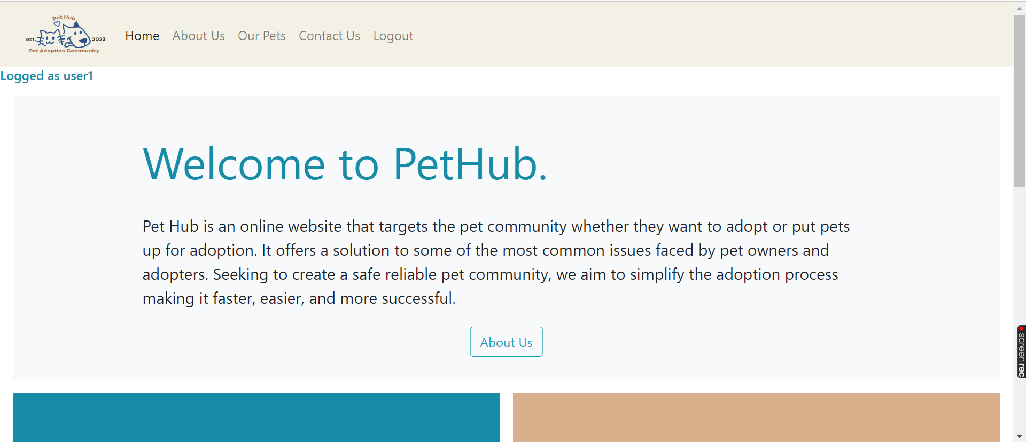

About Us page

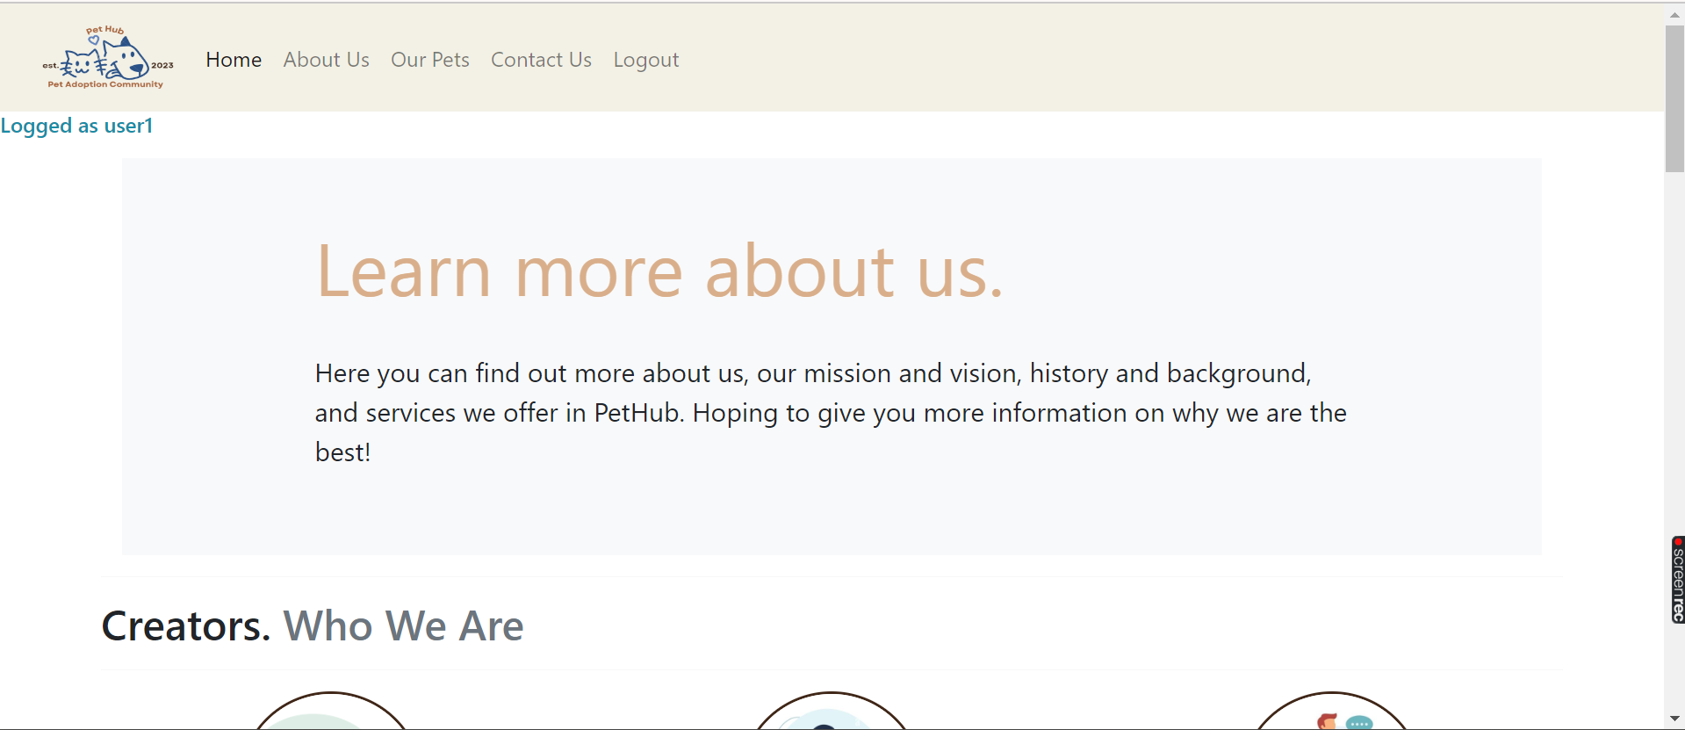

Our Pets page

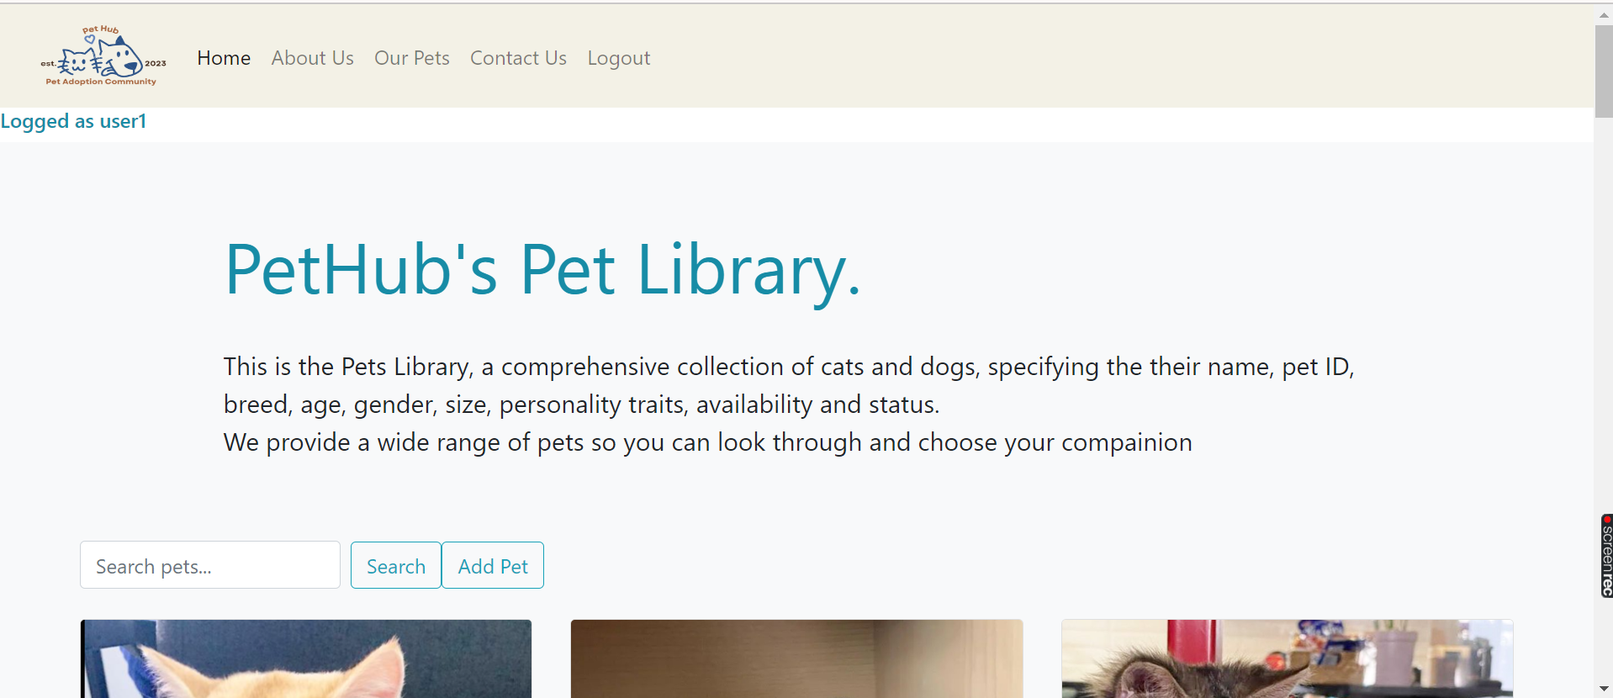

Profile page

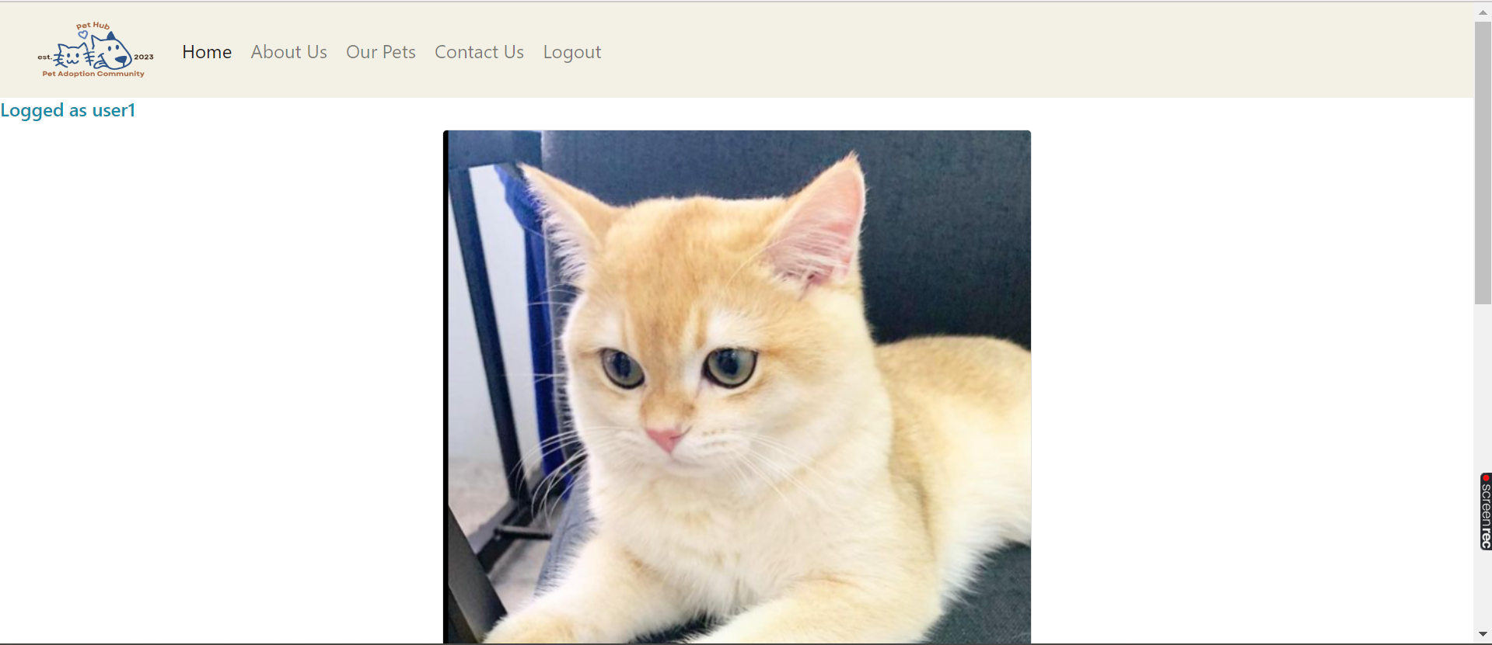

Search page

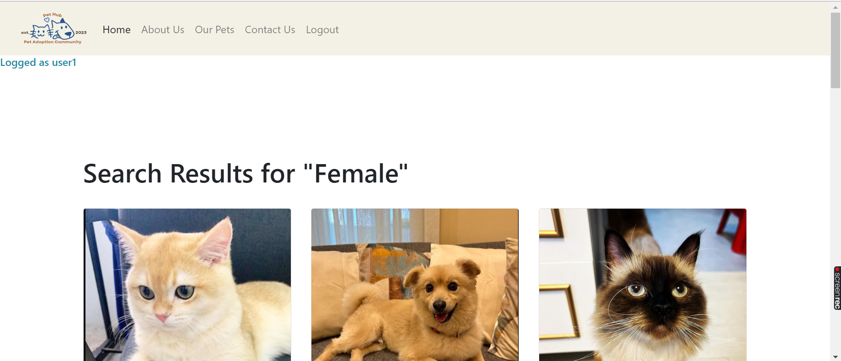

Add pet page

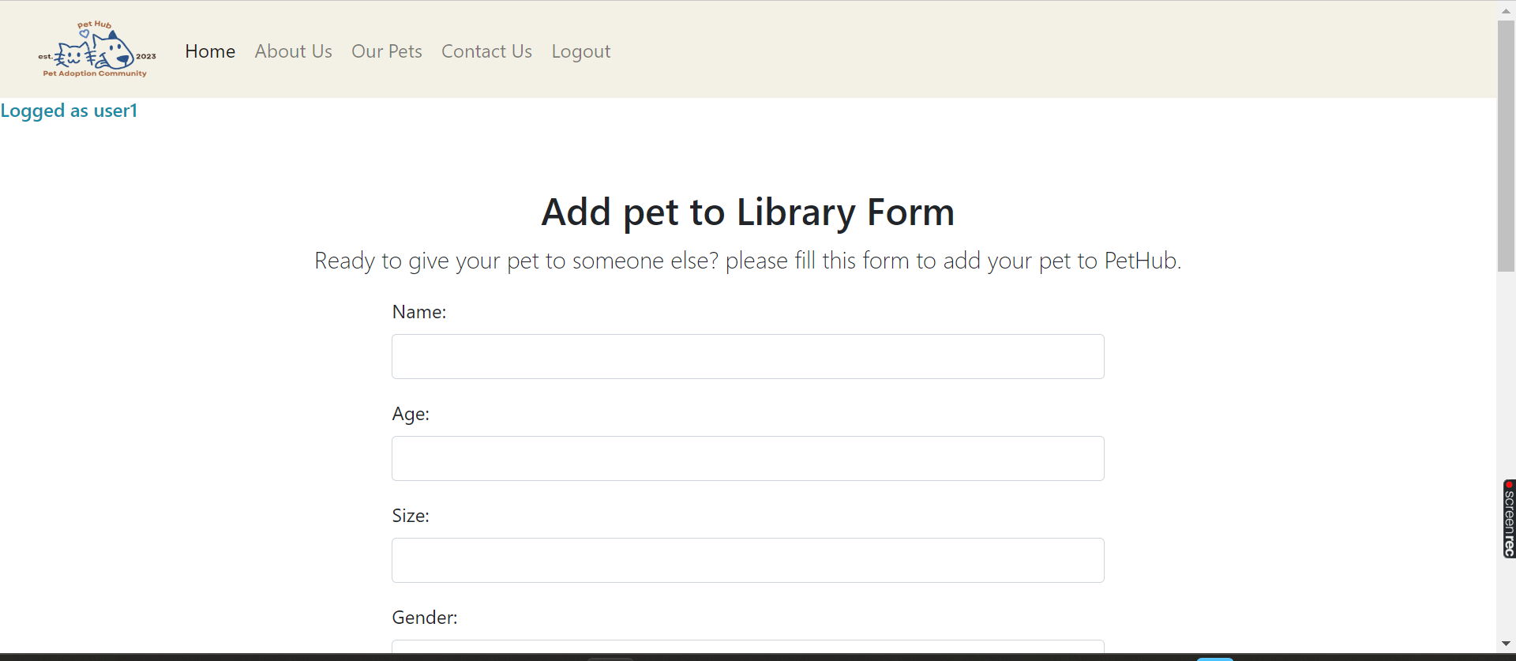

Contact

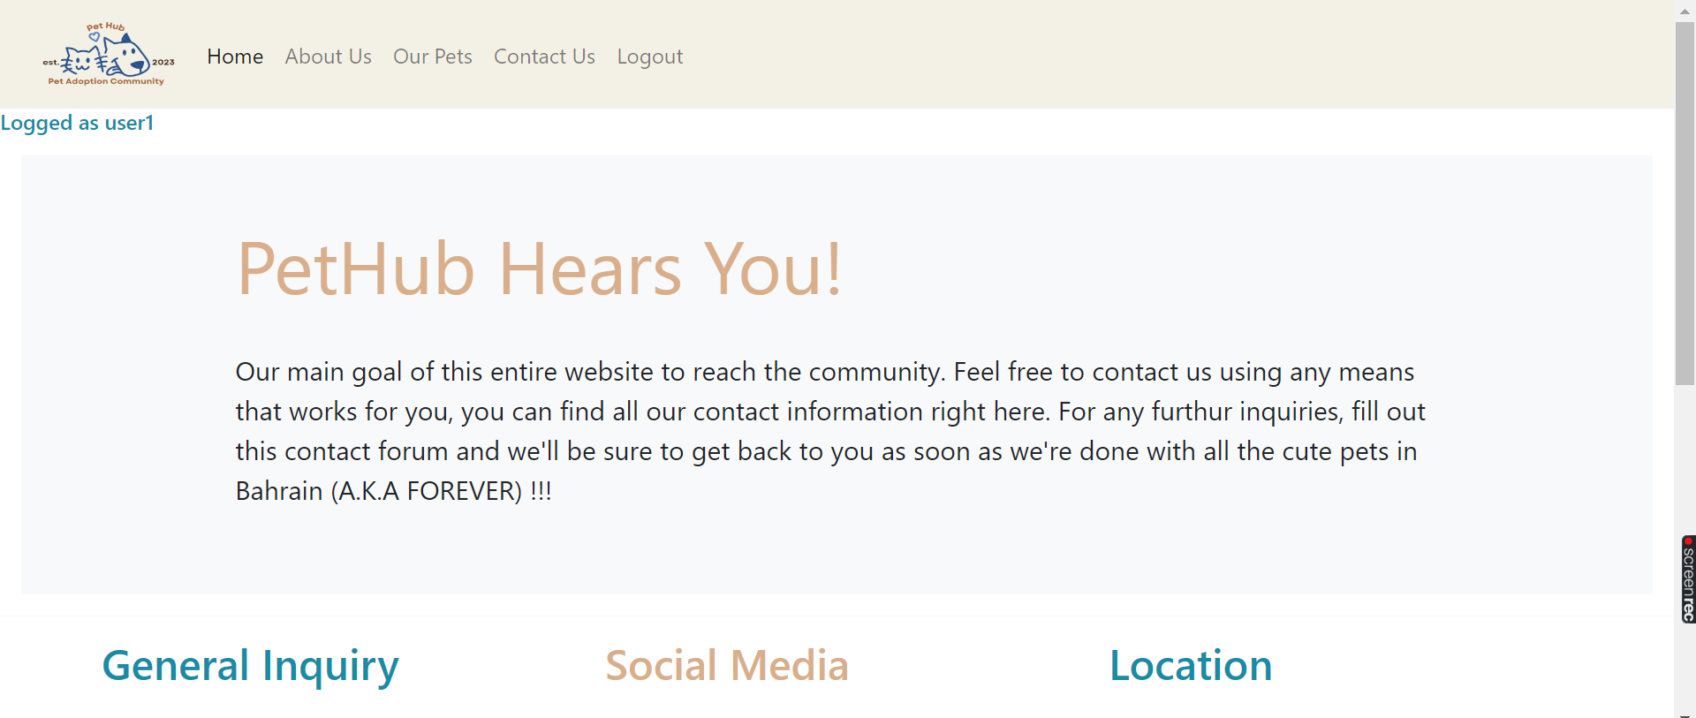

Login

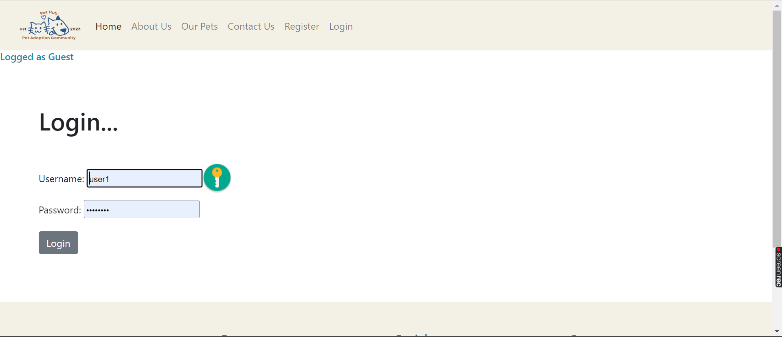

Register

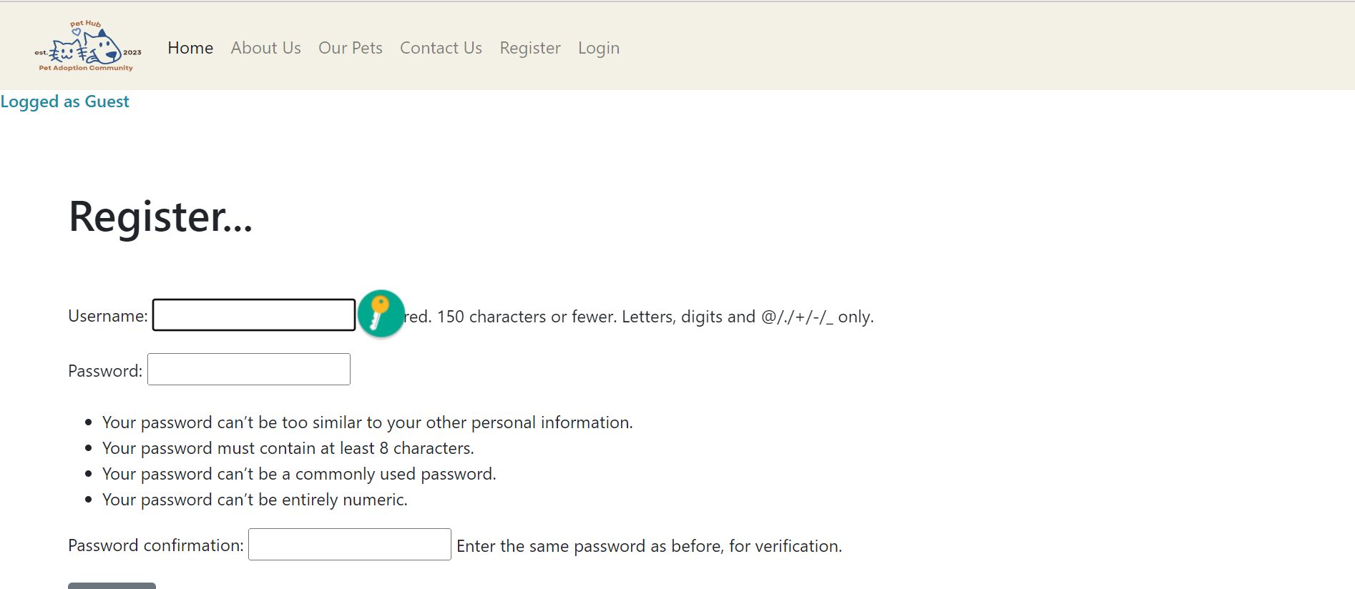

## GIT hub

GitHub repository link: <https://github.com/hindeb/PetHub>

<https://github.com/hindeb/PetHub.git>

## Video

Youtube Link: <https://youtu.be/4_HhdCeDBdE?si=VUhFTnENxQ7-zZWg>

## Reflection

This project was definitely not the easiest to complete, I faced many **challenges** some that I overcame and some I had to work around and admit defeat. One of the issues I faced and fixed was the search function. In my initial plan, I wanted the search engine to modify the same page “pets.html”. However the function would return no results at all under the search bar where the code was located.

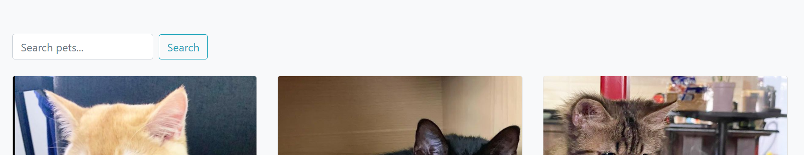

So I adjusted the function to show results in a new page called “search.html” and it worked.

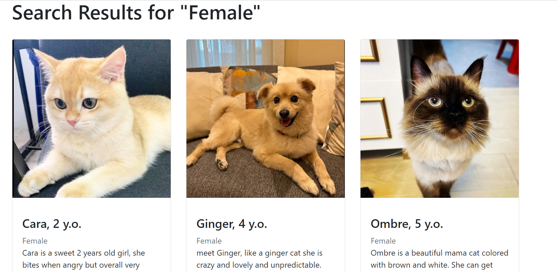

Unfortunately, there were a few issues that I could not overcome and had to leave out of the functionalities. One of them is the Book Meeting and Apply for adoption forms. Initially, the website should’ve allowed potential pet adopters to fill out forms to adopt pets or meet them by going to their profile and clicking on the apply and book option which will take the pet id and display it in the form page.

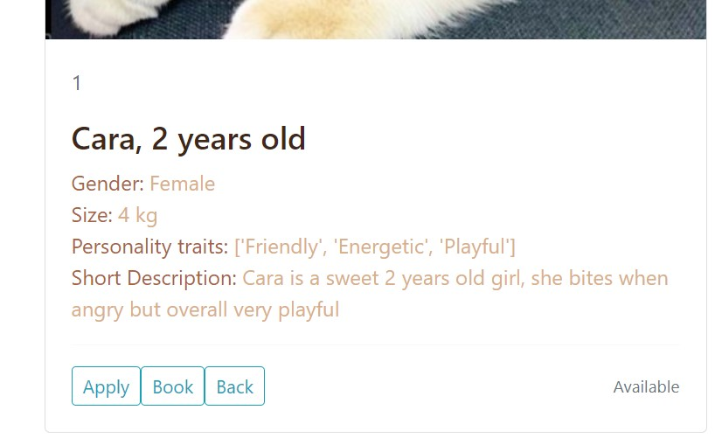

Then I realized that in order for this to work I would have to create two new models and two new forms which would be very time consuming, and I was certain I would not be able to meet the deadline. I gave it two days of hard work, but I decided to exclude it for the project benefit.

I **learned** quite a lot from this course and project. For instance, I learned how to use multiple resources like HTML, CSS and bootstrap to build the front end, and to link Mongo DB database to access the documents in the database collection and build a Django application as the backend. In addition, given the many setbacks I faced in this project I improved problem solving and critical thinking skills to troubleshoot errors and find solutions for my website.

In the **future**, I hope to incorporate more features such as Book Meeting and Apply for adoption, in addition to more data manipulation queries like update pet information or delete pet. I also think creating a customer interactive page or part such as blog or adoption reviews to increase interactivity and engagement.